***Installation Manual***

***Prerequisites :***

*1. Node.js and npm should be installed on your machine.*

*2. Python and pip should be installed for Flask API.*

*3. MongoDB Atlas account for database storage.*

*4. Internet connection to access the Flask API.*

***Frontend Installation :***

*1. Clone the repository :*

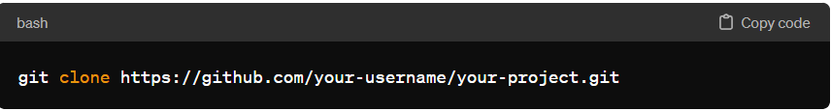

*2. Navigate to the frontend directory :*

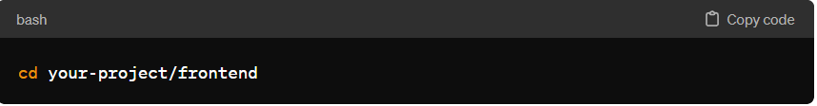

*3. Install dependencies :*

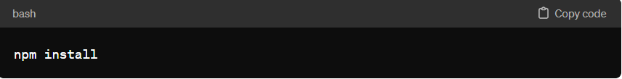

***Backend Installation :***

*1. Navigate to your back-end directory :*

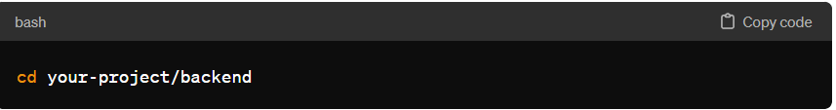

*2. Install dependencies :*

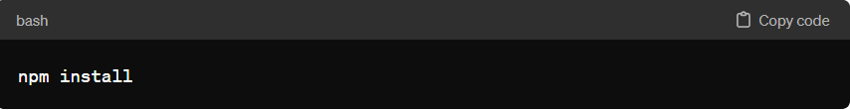

***MongoDB Configuration :***

*1. Create an account on MongoDB Atlas and set up a cluster.*

*2. Obtain the connection URI provided by MongoDB Atlas.*

*3. Replace the MongoDB URI in the backend configuration file (backend/config/db.js) with your c connection URI.*

**Flask API Installation :**

*1. Navigate to your flask API directory :*

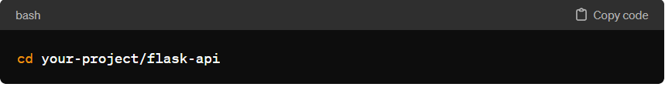

*2. Install Python dependencies :*

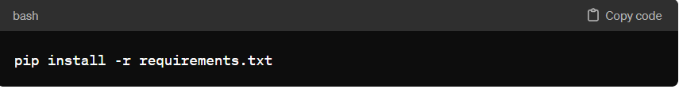

***Running the Application :***

*1. Start the backend Server :*

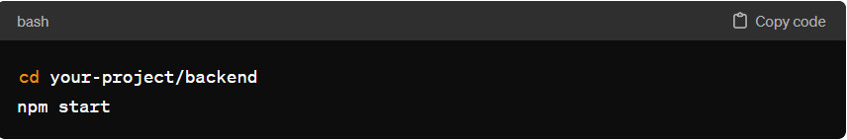

*2. Start the Flask API :*

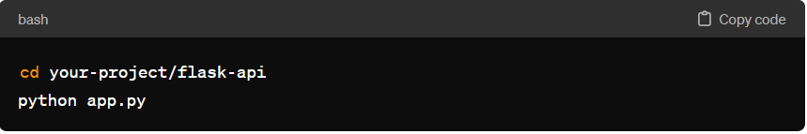

*3. Start the frontend development server :*

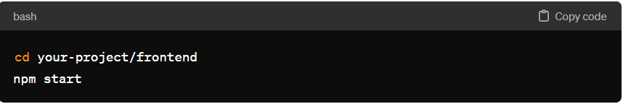

*3. Access the application in your browser at* [*http://localhost:3000*](http://localhost:3000)

***Additional Notes :***

*1. Ensure that MongoDB is running and accessible before starting the backend server.*

*2. The Flask API should be running to fetch predictions from machine learning models*